**ĐỀ 1**

1. Please describe the picture

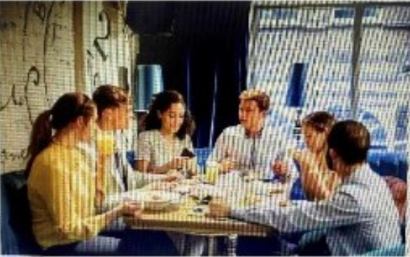

* In the picture, I can see six people. I think they are staying in a restaurant. They are talking about something. They must be celebrating something. Because all of them are looking at the girl who is wearing a white dress, I guess it’s her birthday.
* They are all wearing casual clothes so I guess they are close friends.
* I think they are happy because they are doing what they like
* In the background, I can see a window and sofas
* Looking at the picture, I feel like I want to have a party with my friends right away.

2. Tell me the last time you went to a restaurant with your friends?

* Two months ago

* My friend's Birthday party. She invited me and other friends to attend her party.

+ Enjoy seafood and peaceful atmosphere

* The thing I was impressed most about this restaurant is its professional staff.

They served us so well

3. Why do people enjoy eating out with their friends?

+ Save time as they do not need to spend time preparing meals

+ Having a better view to take some photos and update on Social networks

+ Trying something different

Part 3

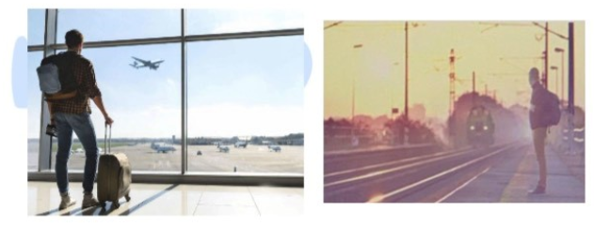

1. Tell me what you see in two pictures?

In the first picture I can see a man. He is at the airport. He is holding his luggage and wait for his flight

In the second picture, there is a man. He is waiting to get onto the train.

So they are choosing different means of transportation

2. Which means of transport do you prefer? Why?

If I have to choose between two options, plane and train, I would choose to go

travelling by train because the ticket price is quite reasonable and it is more affordable, which

helps me save money. For example, Compared to the plane ticket, the train ticket is

three times cheaper. I feel happy when traveling by train.

3. why do people usually not choose to travel by plane?

There are several reasons why people don’t choose to travel plane. The first vital reason

is that The flight ticket is quite expensive so not many people cannot afford it. Another

one is that it is inconvenient in bad weather. Besides, the process of checking-in and out

is time-consuming while people hate waiting for a long time.

Part 4

1. Tell me about a time when you achieved your goal?

When?

My goal is to get to my dream university?

However, this university requires a high entrance exam score so I felt nervous and was scared of failing

My parents encouraged so I tried hard and burn the candles at both ends

at that time, I only slept for 4 hours a day

Finally, I did well and received high scores

I was lucky to Receive the college admission letter and my family was happy because I achieved my big goal.

2. How do you feel about it?

I felt phenomenal when I achieved my goal

3. What do people need to do to achieve their goals?

They need to Be calm

Be stronger

Think carefully make a detail plan what should do to make sure that they go in the right direction

BE persistent and try hard

**DE 2:**

1. Miêu tả tranh

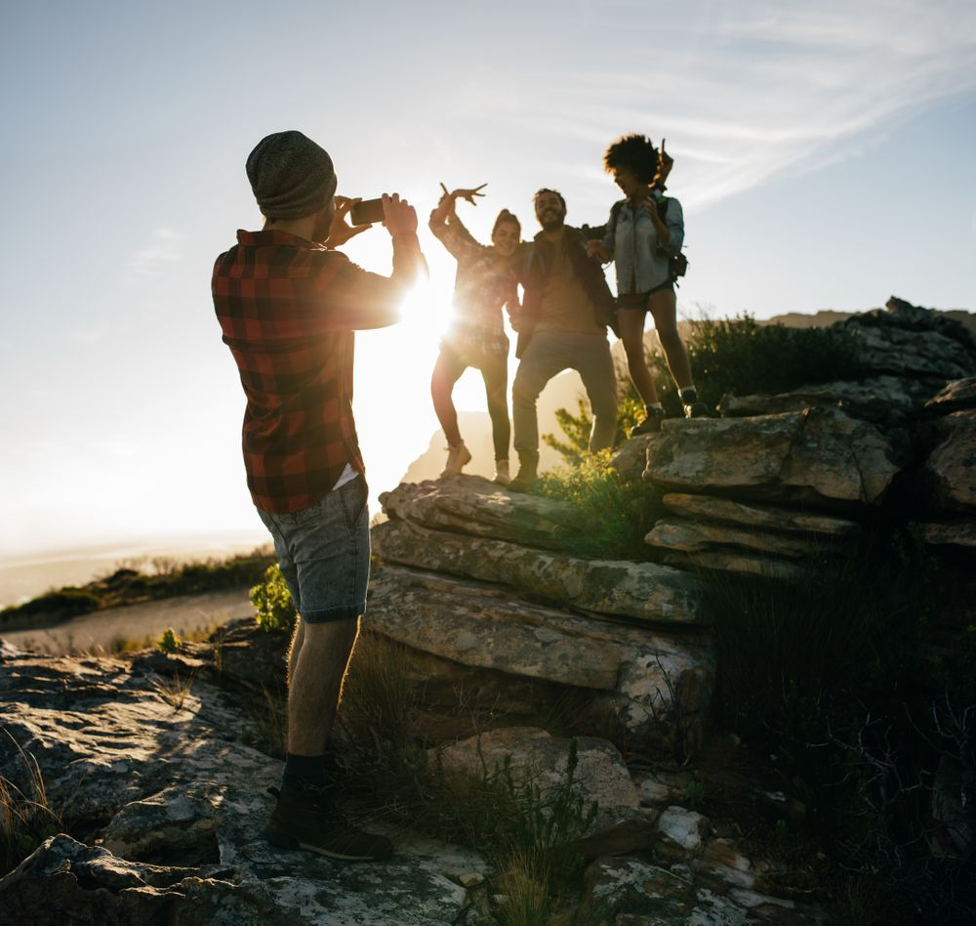

2: Tell me about a time when you went somewhere with your friends?

The time when I went somewhere with my friends was six weeks ago. As I can remember, we had a three-day trip to Danang. We went from Hanoi by train so it took us three hours to get to Danang.

3: What is the benefit of doing/ working with others?

There are many merits of doing things with others. Firstly, the more the merrier.

Secondly, we can do work faster when many people give their hands to finish work. Thirdly, we can learn from experience or knowledge from others.

Part 3:

1. Miêu tả 2 tranh

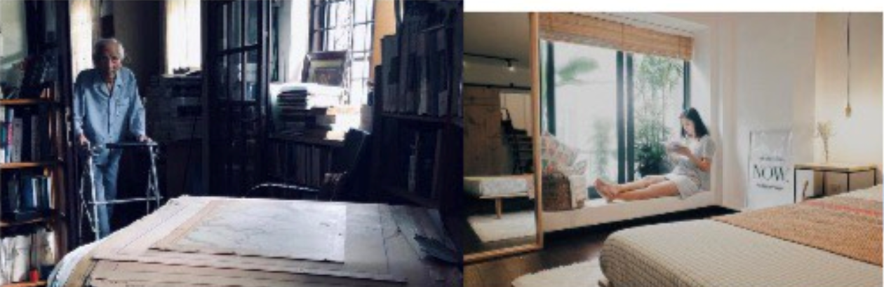

Both pictures show people immersed (mải mê) in reading books.

In the first picture, there is an old man walking in a room filled with books. He appears to be trying to find a book in this room. I guess this is a library in a nursing home. He seems to be lost in thought, absorbed in the world of books.

While in the second picture, there is a young girl sitting on the window in her bedroom. She has a book in her hand and a look of concentration on her face as she reads. Though the picture is a bit blur, the girl seems to be content in her reading, lost in the story unfolding before her.

Although they are at different places, they both seem content and happy in their own way.

Looking at the pictures, I want to curl up with a good book in a cozy room like them too.

2. Which room do you prefer to live in?

To be honest, I prefer to live in a room like picture 2 because I like the design and the decor of this room. It is also painted in my favorite color. Everything is simple. Maybe, I will decorate my room with this design.

3. Why do people like decorating their houses?

People like decorating their houses because it allows them to personalize their living spaces, express their creativity, and create a comfortable and visually appealing environment.

Part 4: Material possession

Q1: Tell me about a time when you cannot buy the thing that you want?

People like decorating their houses because it allows them to personalize their living spaces, express their creativity, and create a comfortable and visually appealing environment.

Part 4: Material possession

Q1: Tell me about a time when you cannot buy the thing that you want?

Well, actually, there are many times when I cannot buy the thing I want or really. However, one of the most memorable times I want to share is the one when I was a freshman in university. At that time, I was a student and had a tight budget. One time, my phone was very old and I really wanted to buy one but actually I did not have money to buy. I also thought that I could ask my mom to buy it for me but you know my parents only had enough money to support me in tuition and living expenses. So, I still used the old phone.

Q2: How did you feel that time?

I felt a little bit sad but at that time, I thought I could try hard to earn money to buy it.

Q3: Material possession alone cannot make people happy. Do you agree/disagree?

I agree. Material possessions alone cannot guarantee happiness. But without money, people have never been happy.

**DE 3**

P2:

1, Describe

3 người cầm túi xách shopping

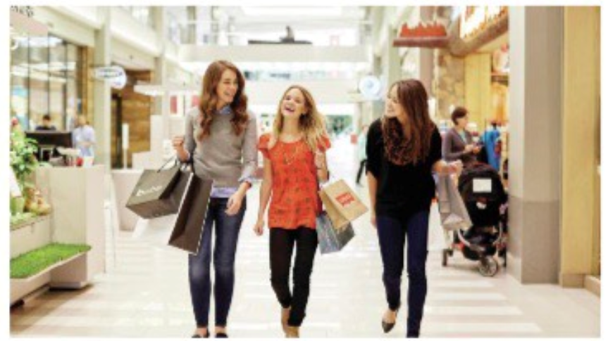

1. Describe the picture?

In the picture, I can see three girls shopping at a mall. They are carrying clothes bags and looking at different items on display.

On the left of the picture, one girl is wearing jeans and a grey sweater while the other two are wearing orange and blakc t-shirts.

I think they are excited because they are having fun trying on different clothes and enjoying their time together.

In the background, there are some stores and mannequins showcasing various outfits.

I guess after this, they are going to have lunch or maybe watch a movie at the mall.

Looking at the picture, I feel like I want to join them and have a fun shopping day with my friends too.

2. Tell me the last time you went shopping?

The last time I went shopping was two days ago. As I can remember, I needed to buy some new clothes for my new job so I went shopping in the shopping mall. I went there with my friends. We went around but I could not find any clothes that suited me.

1. Why do some people not like busy places?

It’s really a hard question because I have never thought about it before. I guess

- It is too noisy, which makes them have a headache when they have to stay there for a long time

- Besides, They may want to focus on their work so they will try to avoid these places..

P3: gia đình trên ô tô / hành khách trên tàu

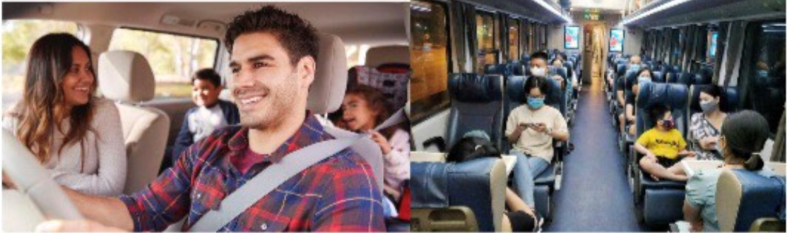

1. Tell me what you see from the two pictures?

Both pictures show people traveling and enjoying their time.

In the first picture, there is a family in a car going on a trip together. The mother is in the passenger seat, smiling and looking at the daughter. The father is driving, with a content expression on his face. In the back seat, there are two children, who seem excited and happy. Overall, the family looks very happy and unified.

While in the second picture, there are many people on a train. From what I can see, they seem to be commuters traveling to work. The train is crowded. They seem busy and occupied, with different expressions on their faces. Some are using their phones, while others are listening to music. It's hard to tell exactly how they are feeling, but I guess they are tired after a long day at work.

Although they are doing different things, they all seem happy in their own way. The family in the car is happy to be spending time together, while the commuters are happy to be going home. Looking at the picture, I want to join the family in the car and go on a trip with my loved ones too.

1. The benefits of traveling by car and by train?

I think that car travel can provide more flexibility and privacy, while train travel is often more environmentally friendly and can offer scenic views and relaxation during the trip.

1. Why do many people like traveling by train?

I guess many people enjoy train travel because it is often more comfortable than other modes of transportation, offers the chance to see new scenery, and allows for socializing and meeting new people.

P4:

1. Tell me a time you must do something that you do not want?

2. How did you feel?

3. How can people overcome such situations?

I usually do not do anything against my will except for the occasions when I need to keep the honor of others. This topic reminds me of an occasion when I did something against my will that I was not very comfortable doing.

It happened about a few months ago as I could not say 'No' on that occasion. It took place during the annual university festival last January. I was asked to host the last day of the event as the student who was selected to host the programme became sick all of a sudden. So, they picked me as the host, and it was so sudden that I could neither deny to host it nor manage enough time to prepare for the event

So terrible.

About the last question, how can people overcome such situations. I think they should think carefully. If they do not want to do things they dislike, just refuse.

ĐỀ NÀY PART 4 CÓ 1 VERSION NỮA LÀ:

1. Tell me a time you laugh really hard?

2. Why did you laugh?

3. Why do people need to laugh?

Q1: There was a time when I laughed really hard during a comedy show I watched with friends.

Q2: I laughed because the comedian's jokes were incredibly clever and relatable. The timing and delivery of the humor were spot-on, which made it genuinely funny.

Q3: People need to laugh for several reasons. Firstly, laughter is a natural way to relieve stress and tension, promoting a sense of relaxation. Secondly, it fosters social connections by creating shared moments of joy and bonding with others. Additionally, laughter releases endorphins, the body's natural feel-good chemicals, which can enhance one's overall mood and well-being.

**ĐỀ 4:**

﻿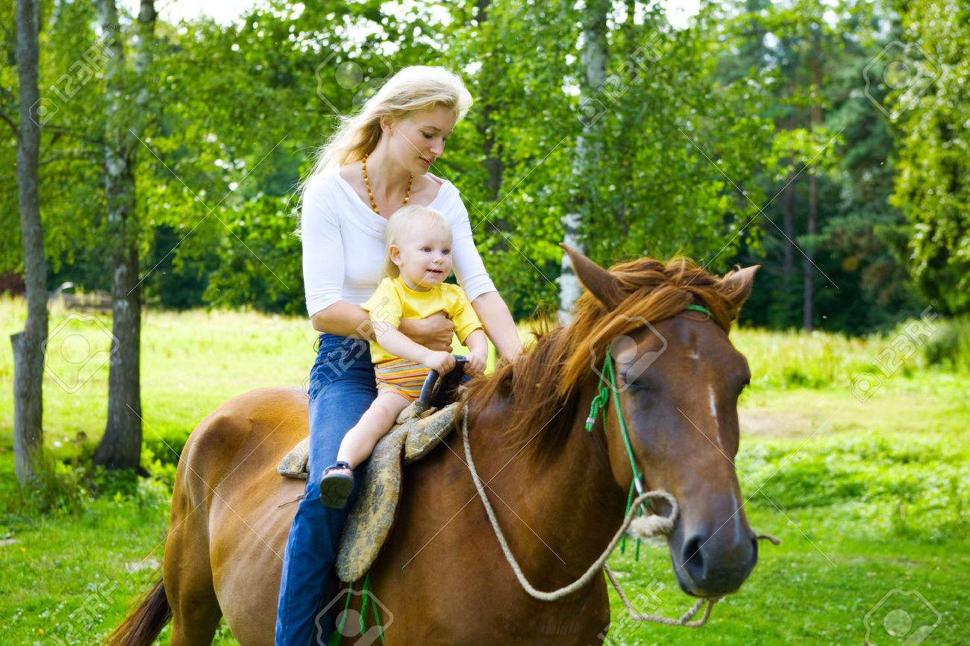

Q2:

1. Describe the picture

In the photo, I see two people riding a horse in the forest. They are the mother and her son, who is around two years old. The mother is sitting behind him, holding him tightly as they both enjoy this new experience. The weather seems pleasant, and the background is filled with trees and a white fence. In the distance, I can make out some trees and houses, but it's not very clear. I think they are very happy because they are spending quality time together. After this, I imagine they will head back home." Looking at the photo, I feel a strong desire to join them and experience the beauty of nature on horseback with my loved ones.

2: Tell me about an animal that you like?

A dog is the one I like. I find dogs to be very useful house pets. It looks so cute and loyal. I love dogs very much because dogs are a part of my life, a small member of my family. Dogs are also my best friends, who are always by my side whenever I am under pressure in life

3: How important are animals in our lives?

Animals play a fundamental role in human life. In agriculture, for example, they are a source of food traction, in addition to the production of milk, wool, and eggs, among other things. Animals are also associated with sports and even recreational activities and companionship.

Part 3: MÙA ĐÔNG RỪNG, MÙA HÈ SA MẠC

﻿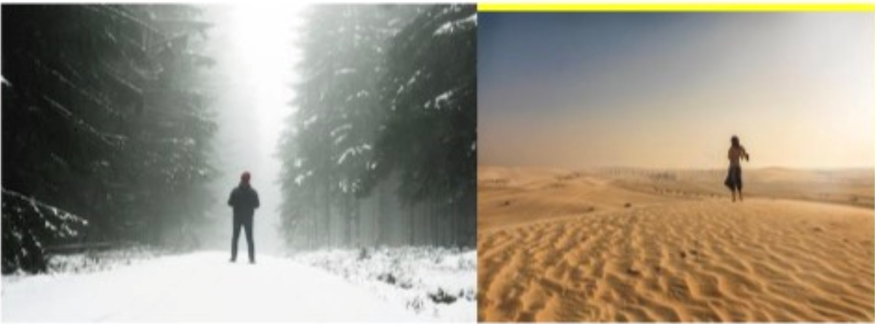

Q1: Describe

Both pictures depict individuals in different environments. In the first picture, we see a man in a winter forest covered in snow. He is wearing a thick coat, scarf, and hat, and seems to be enjoying the winter scenery. In the second picture, a girl is captured in a desert landscape with the sun shining brightly. She is dressed in light clothing and appears to be walking. Although they are in different settings, both individuals seem happy in their respective environments." Looking at these pictures, I want to experience the beauty of nature in different seasons and climates, just like they do.

Q2: What types of people live in these two places?

In the first place, Africans often live here. They have dark skin and are used to low temperatures in hot weather. Secondly, Europeans live here. They have fair skin and are used to low temperatures in extremely cold weather

Q3: Which place do you prefer?

I love winter. Under the cold weather, I usually stay indoors and enjoy the warmth of a cup of hot chocolate or spend time with my special lover during Christmas. It will make my sleep better and I can sleep anytime

Part 4:

1. Tell me a time when you had many choices.

2. How did you feel?

3. Do you think we have so many choices to decide?

In my life, I have experienced many times that I have to make decisions among various choices. Now, I am going to talk about a time when I had to consider different choices. As I can remember, it was a year ago. At that time, I had just finished my entrance exams and needed to choose a university to attend. I had several options like Hust, Neu, Hanu and so on. I didn't know which school would be the best suit for me. It took me a week to think about it and make the final decision. It was very hard but I only chose one.

The last question. I think now, we have a lot of options for one single thing in life so we need to consider carefully.

DE 5

1. Describe the picture?

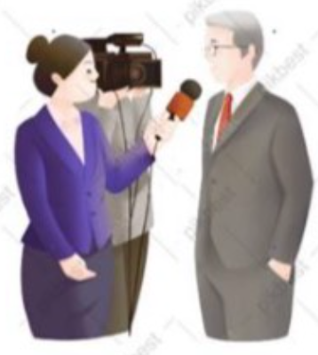

Looking at the picture, I can see three people, two men and a woman. The woman is an interviewer, a man holding the camera may be a cameraman and another man wearing suits may be a businessman. I think they are having an interview. They look so professional.

2. Do you prefer reading newspapers or watching news?

When it comes to my preference between reading newspapers and watching news, obviously, I prefer watching news as watching news is so fast and I can capture the important points. Besides, watching news might be more interesting thanks to sound and visual effects.

3. Why do people need to watch the news?

There are many reasons why people need to watch the news. The first important reason is that watching news can help them update recent news in the country and all the world. So you know bad news like pandemic, crisis and so on to prevent and avoid.

Part 3:

1. Tell me what you see from the two pictures?



Looking at the first picture, I can see a girl. She is reading books at the library. She seems very attentive. Looking at the second one, there is a girl. She is writing something on paper and looking at the laptop, I guess she is reading materials on the laptop and taking notes. Therefore, the difference between two pictures is that one picture is the traditional way of reading while the other is the modern way of reading.

2. Do you prefer reading printed books or e-books?

I prefer reading e-books as it is convenient. E-books are portable so I can bring them to every place without being afraid of the heavy. But, printed books are also good.

3. Does technology affect the way we read books?

Yes, of course. The advance of technology is sharply changing our reading habit. In the past, people read printed books to gain knowledge o find material. They bought them from the store or borrowed books from the library. However, now, with the support of Technology, people can read books on their laptop or phone. Many books are available on the Internet without charging fees, which allows people to read free books.

Part 4:

Tell me a time when you were in a hurry?

How did you feel?

Modern life makes us busier and more rushed. What do you think?

Giải:

One time I was in a hurry was when I was running late for an important meeting. I had overslept that morning and had to rush to get ready. I was so busy trying to get out the door that I forgot to eat breakfast. By the time I got to the meeting, I was feeling stressed, hungry, and out of breath.

I felt stressed, panicked, and overwhelmed. I was worried that I would be late for the meeting and that I wouldn't be able to present my information well. I also felt physically uncomfortable because I hadn't eaten anything.

I agree that modern life makes us busier and more rushed. We are constantly bombarded with information and stimuli, and we are often juggling multiple tasks at the same time. This can lead to stress, anxiety, and burnout.

I think it is important to find ways to slow down and relax in our busy lives. We need to make time for ourselves to de-stress and recharge. This could involve spending time in nature, practicing yoga or meditation, or simply spending time with loved ones.